***Photography***

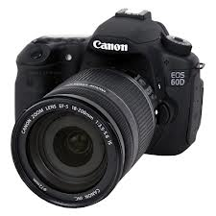

There are many things people enjoy doing. Also, there is an abundance of people who enjoy art. Another thing about art is that it has multiple types. Some types of art include….. **drawings, paintings, spray paint, photography, tape** and so on. The type of art I am helping you learn about is **photography.** **Photography** is very common; people use **photography** when they don’t even realize it. All you need for **photography** is a couple of eyes and a camera, either on a phone or a digital camera. Usually people take pictures of what they like or something funny and cute.

**Photography** is used for many things like**, art, visual representation, museums, books, school projects, websites** and much more. There are many things that people enjoy taking pictures of. A few examples include **flowers, leaves, plants, the four seasons, pets & animals,** but those were only a few examples, so there are still various objects to be named. Some people grow up and become professional **photographers.** Some types of **photographers** are for **magazines, pets, models, community events, newspaper, clothes and shoe lines, school pictures, veterinarians, and senior pictures.** People who become professional **photographers** can get paid lots of money, but it depends on the job they get ... **Photographers** usually have a wide range of props for people to use for pictures.

Someday I would like to go to school and college, and I want to emphasize my learning and someday be a professional photographer. In my defense, I believe that this is a beautiful type of art all around the world. There are only certain people with a gift of an eye. An eye means**: to have a talent that when you see something as a photo in your mind and you take a picture of it**. My favorite thing to do of all is photograph.

There are too many things to photograph such as, plants, animals, seasons, books, and enormous other ideas from people. Only there are 2 things you need to photograph (reminder : eyes, camera). Taking a photograph is sometimes easy for some people or may be challenging. Although there are so many types of photographers, it may be hard for them to find jobs at some point.

Now I’ve told all I know about photography for now, but there are still other places where you can learn. If you really believe in yourself, **you have potential** to be a photographer if you choose to.

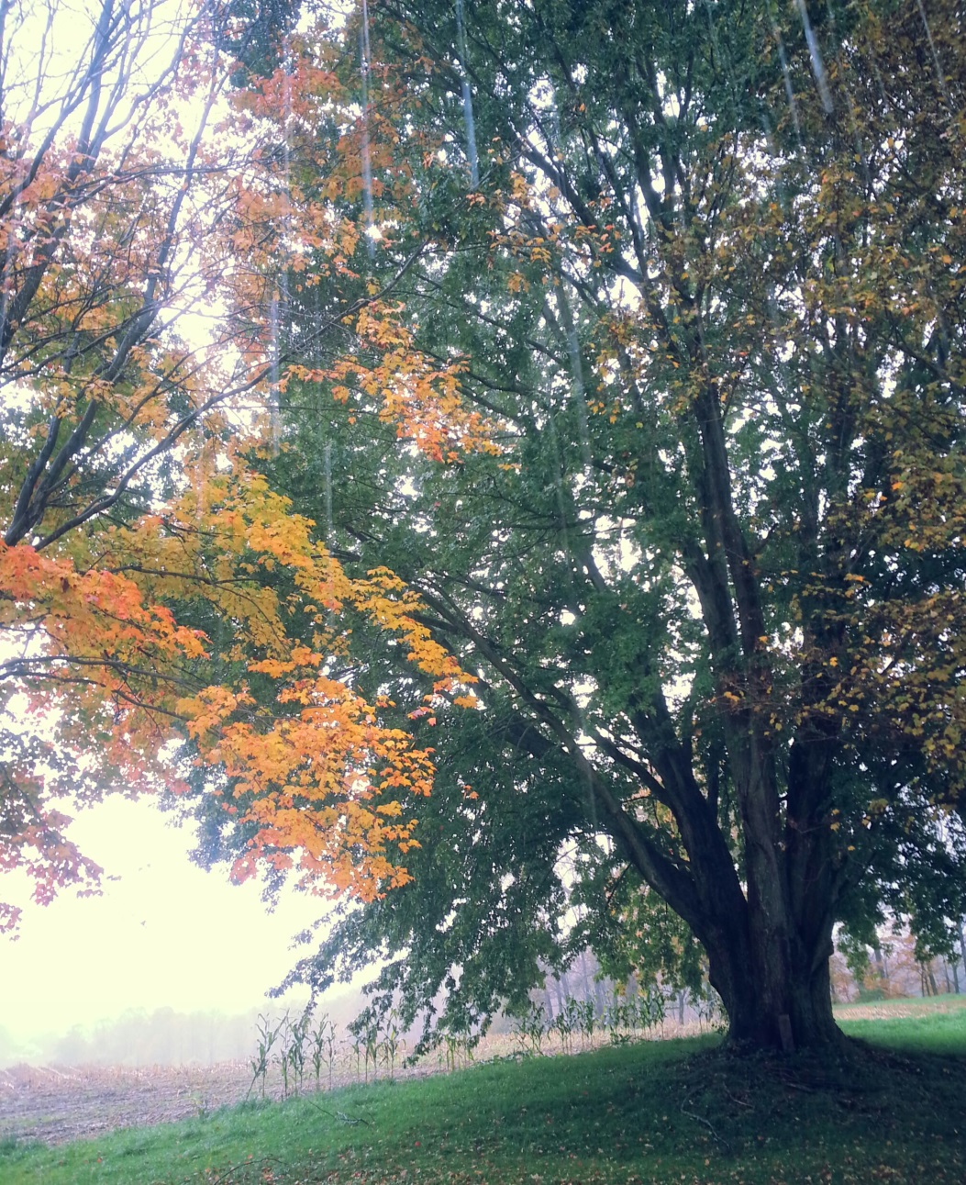

This is a photo I took, and I feel that this photo speaks to me. This photo speaks to me by showing how fall is here and all of the leaves are changing colors. In this photo, if you see that it is raining, and there are so many multi colored leaves. This picture is one of my **favorites**, because it shows the beauty of fall. Also this photo expresses the wonders of that season.