Name: __________________________________________ Period: _______

Use the illustration below to answer questions 1 through 8.
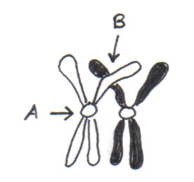
- How many chromosomes are depicted in the picture on the left? ___________

- How many chromatids are depicted in the picture on the left? ____________

- This “set” of chromosomes is known as a ____________________________

- This “set” forms during which stage of Meiosis? ______________________

- The phenomena that is being depicted is called _______________________

- Structure A represents a _______________________________

- Structure B represents _________________________________

- When these pairs come together, it is known as ________________________________

Use the illustration below to answer questions 9 through 11.

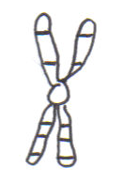
- How many chromosomes are depicted in the picture on the left? ____________

- How many chromatids are depicted in the picture on the left? ____________

- During which stage will you find structures (that look just like this) lined up at the cell equator?

Use the illustration below to answer questions 12 through 15.

- How many chromosomes are depicted in the picture on the left? ____________

- How many chromatids are depicted in the picture on the left? ____________

- In what stage of a human cell process would you find 46 of these structures in a newly produced cell?

- In what stage of a human cell process would you find 23 of these structures in a newly produced cell?
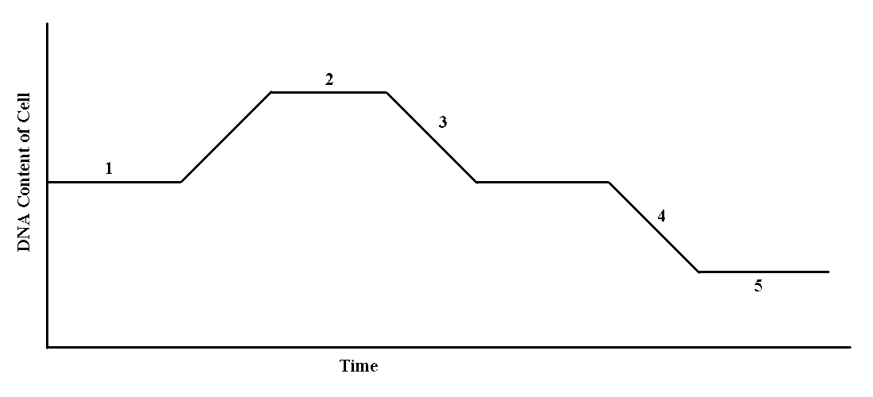
Use the illustration below to answer questions 16 through 19.

- What process is being shown above? ____________________________________

- What number indicates sister chromatid separation? _______

- What number represents homologous chromosome separation? _______

- Label the graph with an “S” where DNA synthesis occurs.

- A human cell is considered 2n = 46.

  - How many chromosomes would in a cell at the end of telophase II? _______

  - How many chromosomes would be in prophase I? ________

  - How many chromosomes would be in metaphase II? _______

  - How many chromosomes would be in each cell at telophase I? _______

  - How many chromosomes would be in anaphase of mitosis? _______

- A cell with 40 chromosomes (the diploid number) goes through the cell cycle. What is the number if chromosomes after doubling the DNA in the S phase?

- How many chromosomes will a cell have during mitotic anaphase if the diploid chromosome number is 6?

