Name: _____________________________________________ Period: ___
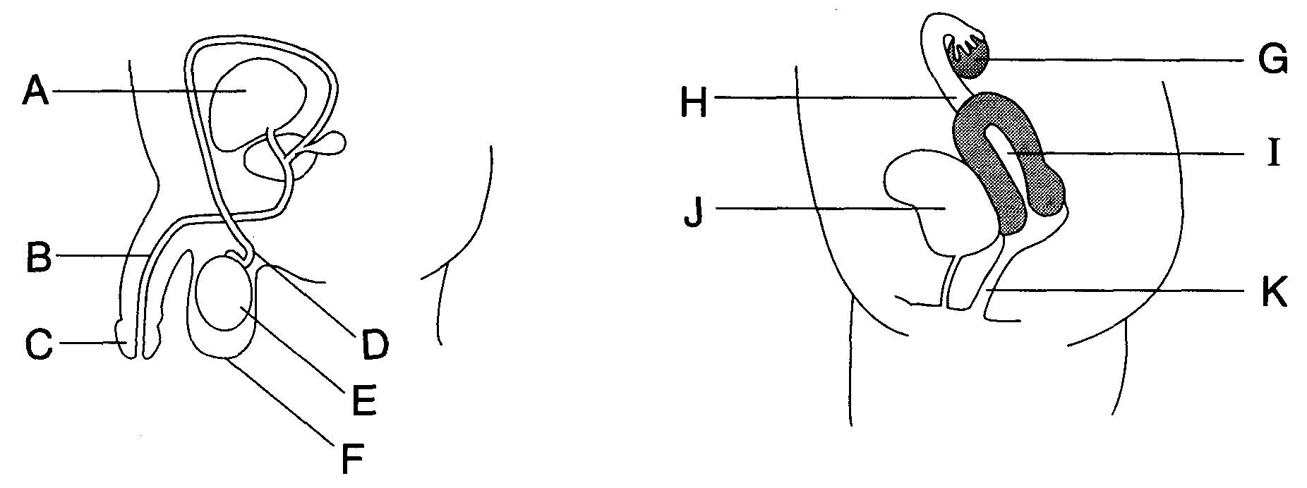

- Fill in the chart below.
STRUCTURE | NAME | FUNCTION
A and J | Bladder | Stores Urine
F
E
E | Testes (Interstitial Cells)
 | Vas Deferens
B
C |  | Used for internal fertilization  (I had to fill it in….who knows what you would have written here)
 |  | Makes Eggs, Estrogen, and Progesterone
H
 | Uterus (Entire Structure)
 | Uterus (Endometrium)
- List any three hormones of the menstrual cycle and list their function.

- Give two ways in which the processes of oogenesis and spermatogenesis differ.

- Give two ways in which the processes of oogenesis and spermatogenesis are similar.

- What are the three secretions of the seminal vesicles and explain how they benefit sperm cells?

- What is the function of the epididymis?

- What is the purpose of prostate secretions?

