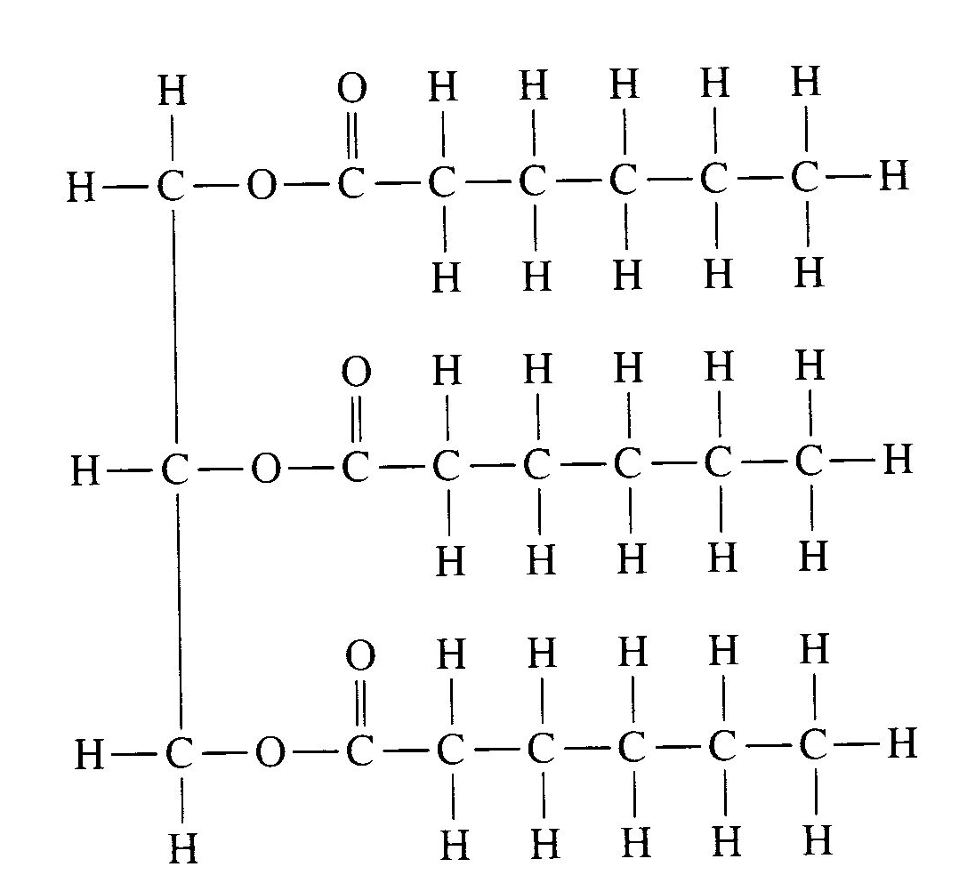
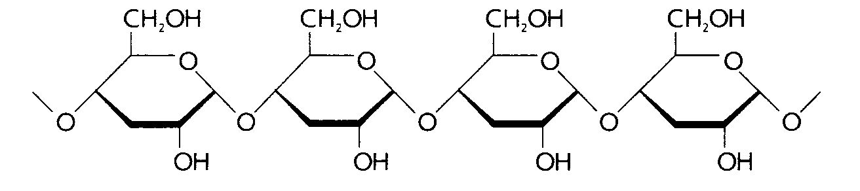
Name: ___________________________________________

Period: _________

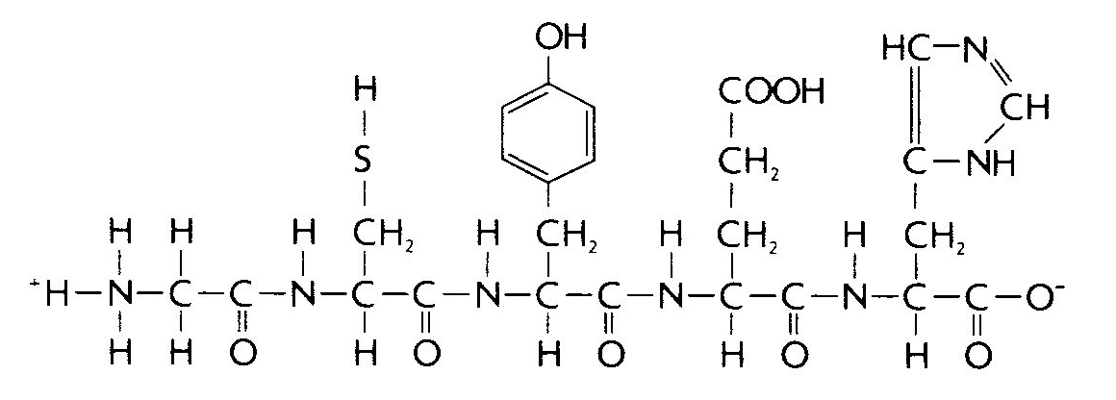
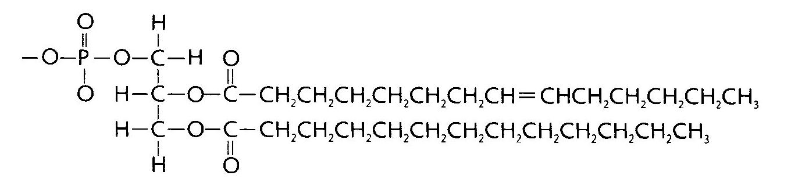
Diagram | Polymer | Monomer(s) | Bond Name | Functional Groups | Function(s) of Polymer
1
2
3
4

