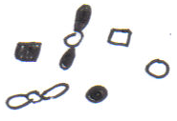
Normal Diploid Cell 2n = 6
Prophase
Metaphase
Anaphase
Telophase
Prophase I
Metaphase I
Telophase
I
Metaphase
II
Telophase
II

