Name: ___________________________________________ Period: _____

- Fill in the chart below.
Plant Structure | Where it is found? | Function
Apical Meristem
Anther
Cotyledon
(Endosperm)
Cuticle
Guard Cells
Ovary
Palisades Mesophyll
Polar Nuclei
Radicle
Root Cap
Spongy Mesophyll
Stomates
Vascular Cambium

- What is the difference between apoplastic and symplastic water movement in root tissue?

- Active transport is used at various times within plant tissue. Identify one way in which active transport is used, where it is used, and why it is used.

- Label the below diagram AND give the function of each structure shown.

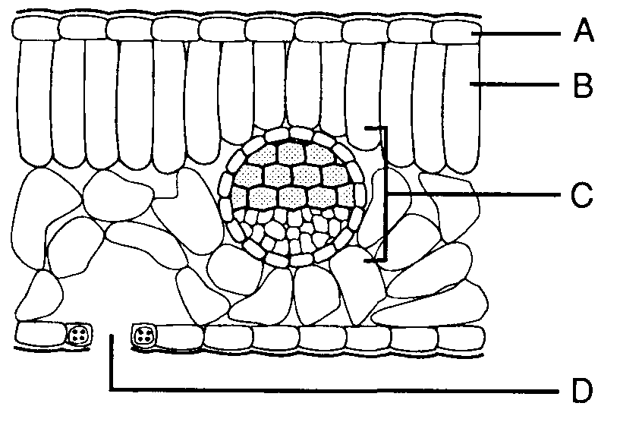

- Fill in the chart below.
Plant Hormone | What it’s Used for?
Ethylene
Auxins
Abscisic Acid

- Preventing water loss in plants is crucial. List any two ways in which plants can maintain a stable internal balance of water WITHOUT mentioning stomates.

- Angiosperms experience a double fertilization during reproduction. Identify BOTH fertilizations. Explain the cells involved and what is formed from each.

