Name: ___________________________________________ Period: _____

- What is the difference between apoplastic and symplastic water movement in plants?

- How can you differentiate between a monocot and dicot stem?

- Draw a brief sketch of a monocot and dicot root cross-section and explain a major difference between them.

- Label the below diagram AND give the function of each structure shown.

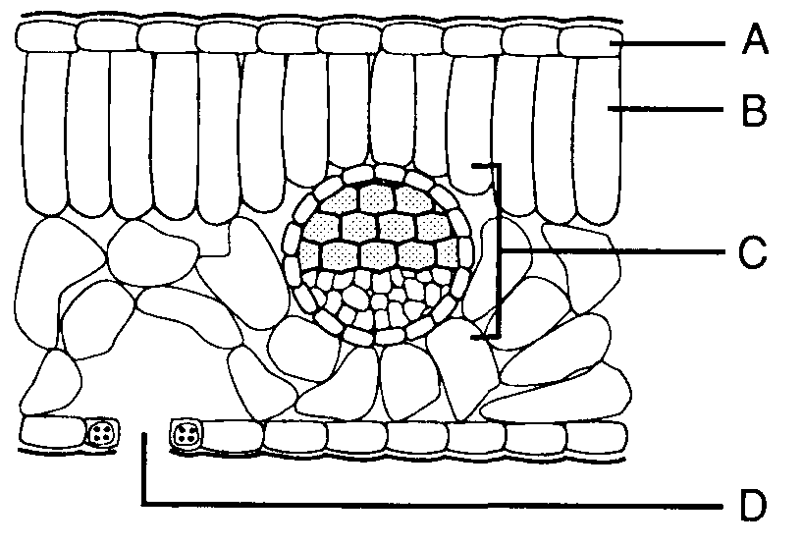

- Identify and briefly sketch the two different types of xylem cells found in plants. Give two differences between the cells.

- Which vascular tissue is dead at maturity? Which is simply missing some organelles?
Plant Hormone | What it’s Used for?
Cytokinins
Ethylene
Auxins
Abscisic Acid

- What is the difference between the cork cambium and the vascular cambium?

- You may have to look this one up, kids. What is bark made of?

- Give a brief sketch BUT FULLY LABEL a section of phloem.

- List two conditions that would keep stomata open.

- Fill in the below chart below.

