TOPIC 11
ROCKS & MINERALS

- Minerals are .

Or

- Rocks are .

Minerals
- Defn: naturally occurring, inorganic elements or compounds .

Mineral Properties
- Used to minerals

- Color
- in identifying minerals.

All of these are varieties of quartz!
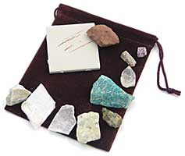
- Streak
- The color of a minerals .
- “ ”
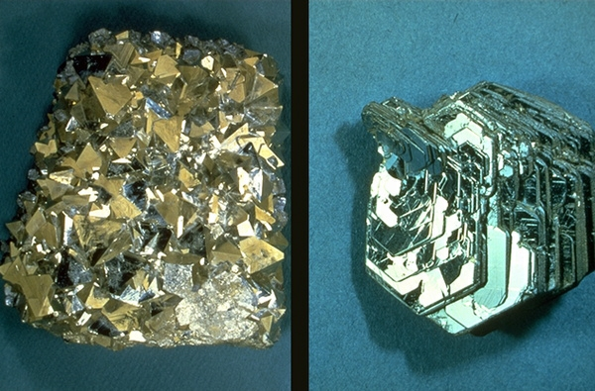
- Luster
- How the minerals surface .
- vs. .

- Hardness
- The ability of a mineral to .
- “ ”

- If mineral A can scratch mineral B, what does that tell us about the relative hardness of each mineral?

Moh’s Hardness Scale
Soft

Hard

5. Fracture/ Cleavage
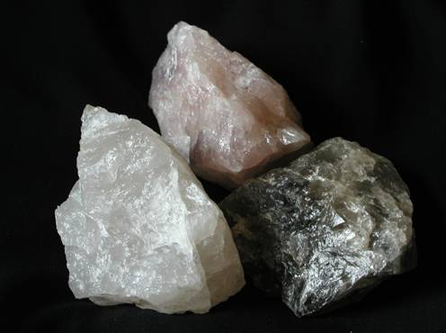
Fracture
- Mineral breaks .

Cleavage
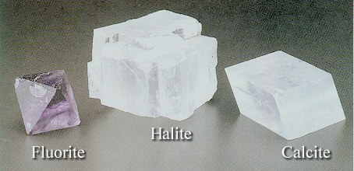
- The tendency of a Mineral to break along its weakest plane.

- Crystal Form
- Some minerals tend to form crystals that aid in the identification of the mineral.

- Specific Gravity
- The ratio of the density of the mineral to the density of water (1 g/cm³)

- If a mineral has a specific gravity of 5 that means it is 5 times as dense as water.

- Others
- Acid test –
- Magnetic –
- Taste -
- A minerals properties are due to the internal arrangement of its atoms.

Silicate Minerals
- Minerals that contain a combination of .

Silicon-oxygen tetrahedron
The basic structural unit of silicate minerals
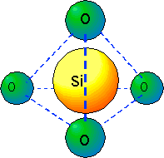
Drawing:

Rocks
- Rocks are classified by !

Sedimentary Rocks:

Clastics
- Rocks that form (sand, silt etc.) are .

Processes
- .
- Vary due to ! (see ref tables p. 7)

Non-Clastics
Organics (bioclastics)
- Form from .

Examples:

Chemical (crystaline)
- Formed from the of sea water.

Examples:

Igneous:
- Form when liquid rock and .

Intrusive

- Cools the earth’s surface (slowwwwly!)

Extrusive
- Cools (quickly!)

- The the rock takes to cool, the the crystals!

- Cools slow ….. .
- Cools fast ……. .
- Cools immediately…… .

Vesicular- gas pockets

Metamorphic:
- Rocks that are due to extreme and/or .
- DO NOT MELT!!! (they recrystalize)

Metamorphic rocks become…

- Banding/Foliated

Regional Metamorphism
- Occurs when large areas of rock are changed.
- Usually deep below the surface where crustal plates collide.

- The Adirondacks!

Contact Metamorphism
- Occurs when liquid rock comes into contact with other rocks.

The Rock Cycle

