TOPIC 8
WATER & CLIMATE

What happens to precipitation when it reaches Earths’ Surface?
- .

- .

- .

- .

Regolith-
The unconsolidated earth material at the Earth’s surface.

- .

Porosity
- The % of open pore space between particles.

Permeability
- The ability of a material to allow water to flow through it.

Capillarity
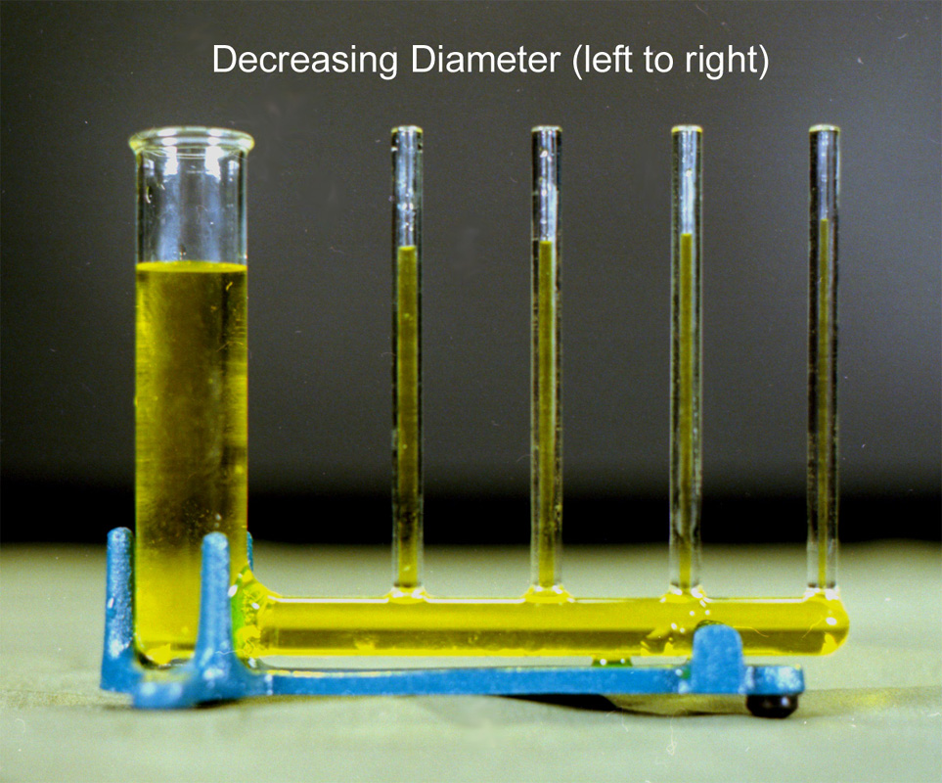
- Upward movement of water due to adhesion and cohesion.

Examples:

- The smaller the particle size, the greater the capillarity.

Factors Affecting Infiltration
- Slope- as slope ↑, infiltration
- Porosity- as porosity ↑, infiltration
- Saturation- as saturation ↑, infiltration
- Vegetation- as vegetation ↑, infiltration
- Permeability- as perm. ↑, infiltration
- Capillarity- as capillarity ↑, infiltration
- Condition of ground

Runoff will occur when…
- The regolith .
- The ground .
- The slope .
- The rate of precipitation rate of infiltration.
- The ground is .

Factors Affecting Climate:
- Latitude
- As the latitude ↑, .
- Moisture → Wet/ Dry Moisture belts (see p14 in Ref. Tables)
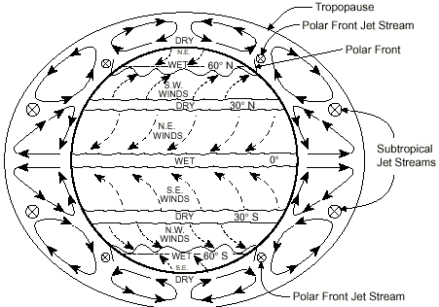

- Elevation
- As elevation ↑, .

- Topography

- Monsoons

Nearness to a Large Body of Water
- .
- .

- Ocean Currents
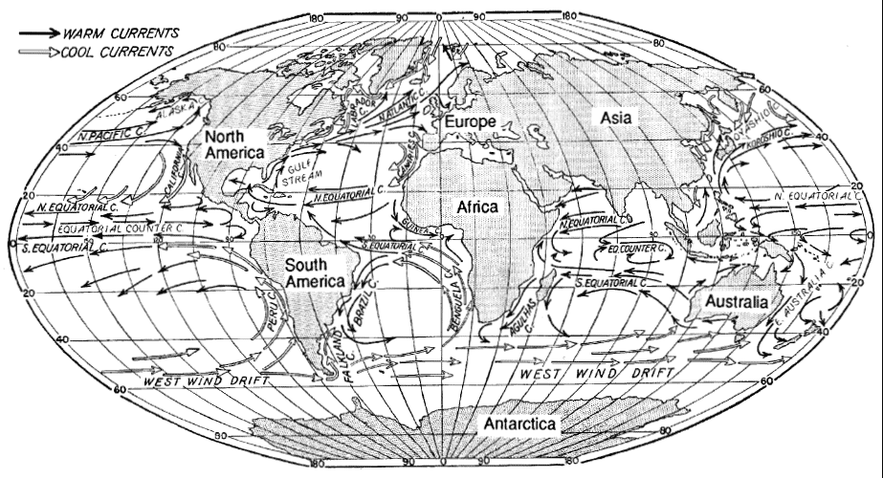
- (see Ref. Tables p. 4)

P/ Ep Ratio
- P = .
- Ep = .

Formula:

Example: The average annual precipitation for Syracuse is 911 mm while the Potential Evap is 636 mm. What is the P/Ep ratio?

Answer:

