Topic 12

The Dynamic Crust

Principle of Original Horizontality:
- The assumption that sedimentary rocks form in .

Drawing:

Evidence of Crustal Change
- .
- Drawings:

- .
- .

“Continental Drift”- Alfred Wegener
Theory: the continents are sliding across the Earths’ surface.

Evidence:

- .

- Pangea- “ ”

Plate Tectonics
Theory:
- Earth’s crust is made up of a variety of plates that are .

Mid Ocean Ridge

Evidence of Sea Floor Spreading

- Paleomagnetism

Drawing:

- Crustal plates move due to convection currents in the earth’s mantle!!!

Plate Boundaries

Oceanic Crust

- basaltic
Continental Crust

- andesitic

Convergent Boundaries
- Oceanic – Continental

Drawing

Features
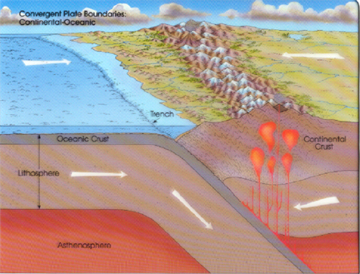
- E-quakes
- Volcanoes
- Trenches

- Mountains

Examples:

- Oceanic – Oceanic

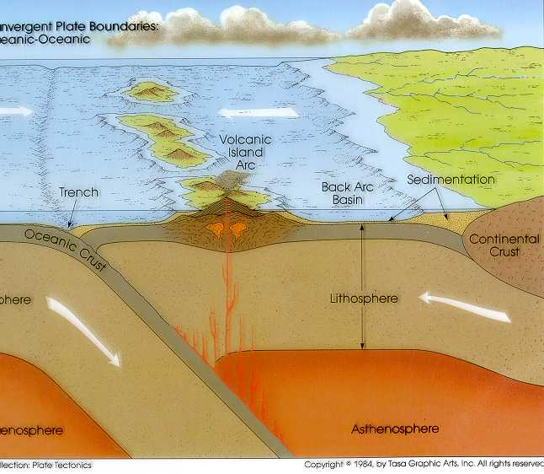
Drawing

Features

Examples:

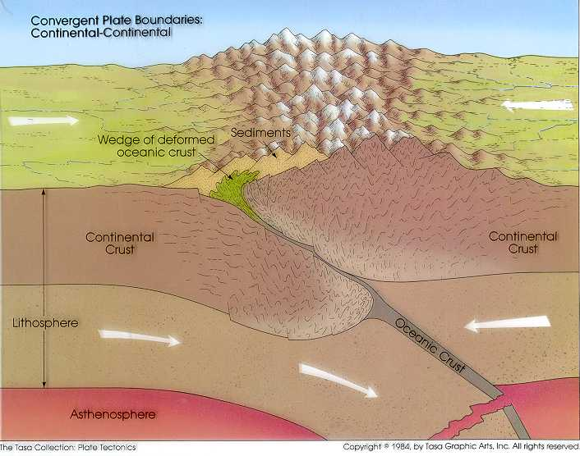
- Continental – Continental

Drawing

Features

Examples:
- Himalayas

Divergent Boundaries:
- Mid Ocean Ridges
- Rift Zones

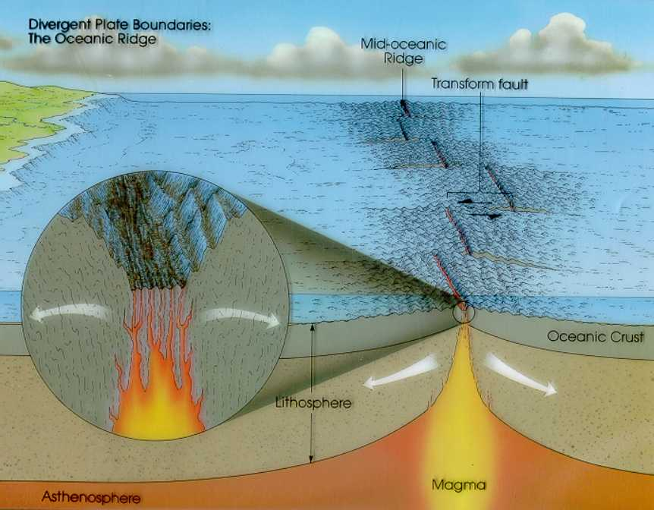
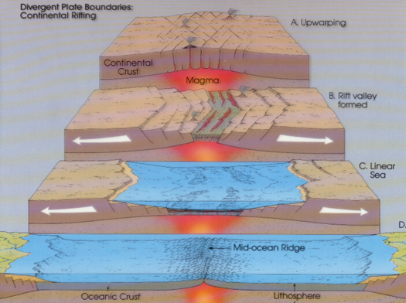

Transform Boundary:
- Boundary where plates .

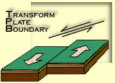

Drawing:

Example:
- San Andreas Fault

“Hot Spots”
- Regions of volcanic (magmatic) activity usually away from plate edges.
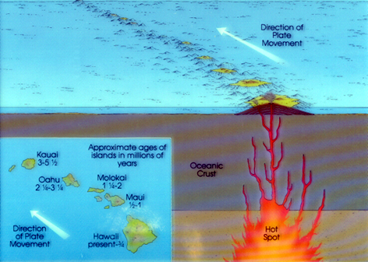

Example:
- Hawaii

- Earthquakes, volcanoes and mountains are usually associated with plate boundaries.
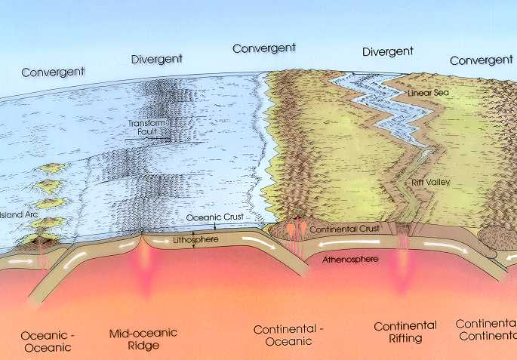

Earthquakes
- The shock wave produced by .

Seismograph-

Focus-

Epicenter-

Seismic Waves

Primary Waves
- .
- .
- .
- .

Secondary Waves
- .
- .
- .
- .

- The between the P & S wave arrival times can be used to calculate the distance from the epicenter.

- To find the epicenter, one must find the distance from at least .

Earth’s Interior:
- See diagram p. 10 in the Earth Science Reference Tables.

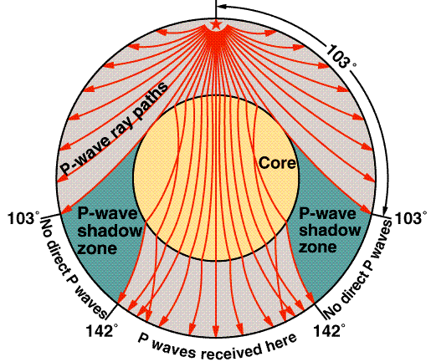
Evidence:
- Seismic Data
- Meteor Composition
- Earths Magnetic Field
- Moon Composition

Tsunami
- Large wavelength ocean wave produced by .

Earthquake Emergency Planning

Individual- “Drop, Cover and Hold”

Community

Volcanoes
- A mountain composed of igneous extrusive rock.

Violent Eruptions vs. Non-Violent Eruptions

