Topic 2: MODEL OF EARTH

Model- something that represents the or of something else.
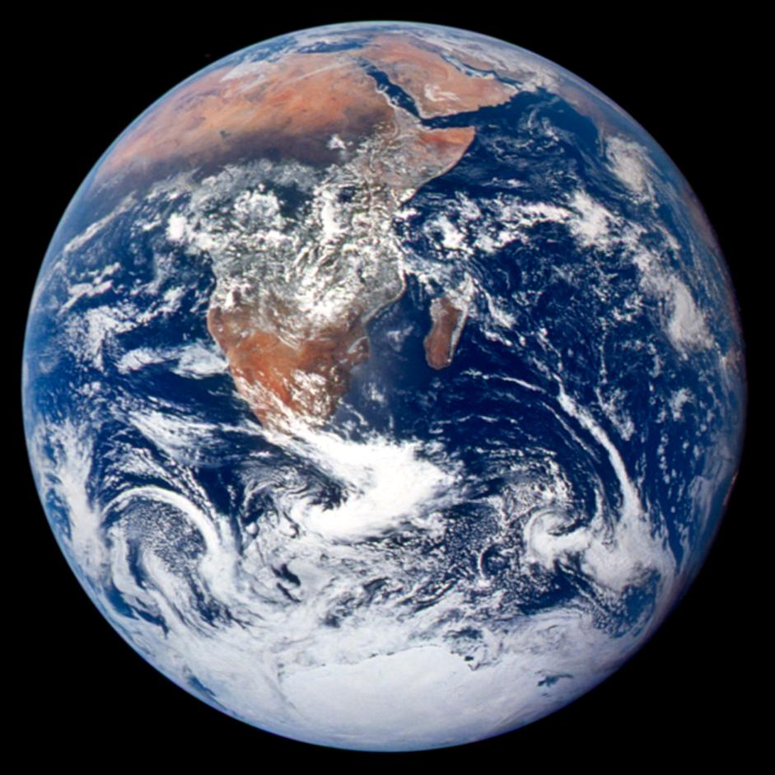

Ex:

Scale- the between the size of the

model and the actual object.

Evidence For Shape of Earth

.

.

.

.

* Best form of evidence

Earths’ Shape

True Shape

.

“Slightly Squatty”

diameter is greater than the diameter.

DIAGRAM

Apparent Shape

“Perfect sphere”

Models, pictures from space, scaled drawings

EARTH COMPONENTS

Atmosphere- Thin layer of that surrounds Earth
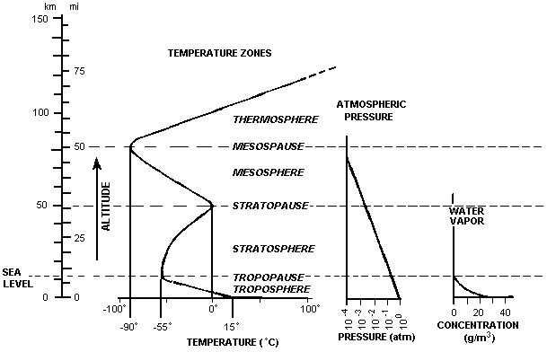

*!* See pages 11 & 14 in Reference Tables

Hydrosphere- of Earths’ surface.

71% of Earths’ surface is covered by .

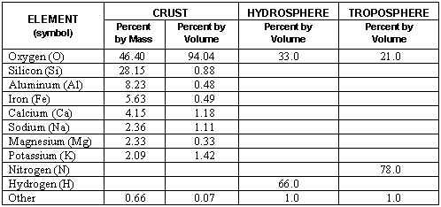

Lithosphere- outer portion of Earth.

*!* See pages 10 & 11 in Reference Tables

Finding Location

Coordinate system- grid system of lines for determining location.
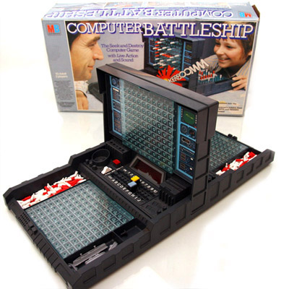

Examples:

Latitude and Longitude

Latitude
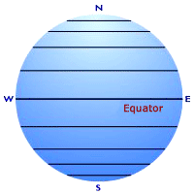

Angular distance north or south of the .

Maximum latitude= º

Latitude = altitude of Polaris!

Longitude
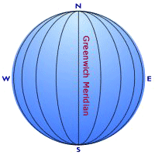

Angular distance East or west of the .

Maximum longitude = º

Longitude is calculated using the difference in local solar time and time at the prime meridian.

Finding Longitude:

Example: An observer measures the local solar time as 3 pm. The time at the prime meridian is noon. What is the observers longitude?

TIME ZONES

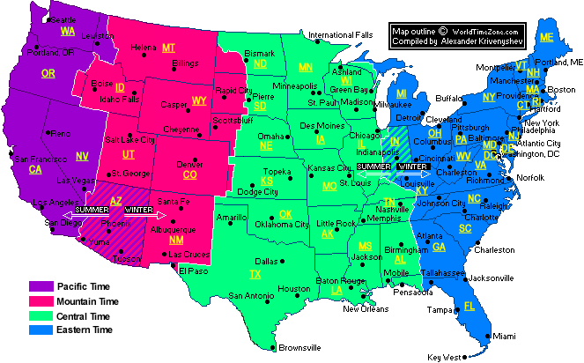

Field Mapping

Field- any area that has a measurable value of a given quantity at every point.

Examples: temperature, magnetic, gravitational, elevation.

Isolines- lines that connect points of field value.

Rules for Drawing Isolines:

. (why?)

Tend to run .

Must at the edge of the map or form a .

“Smooth Curves”
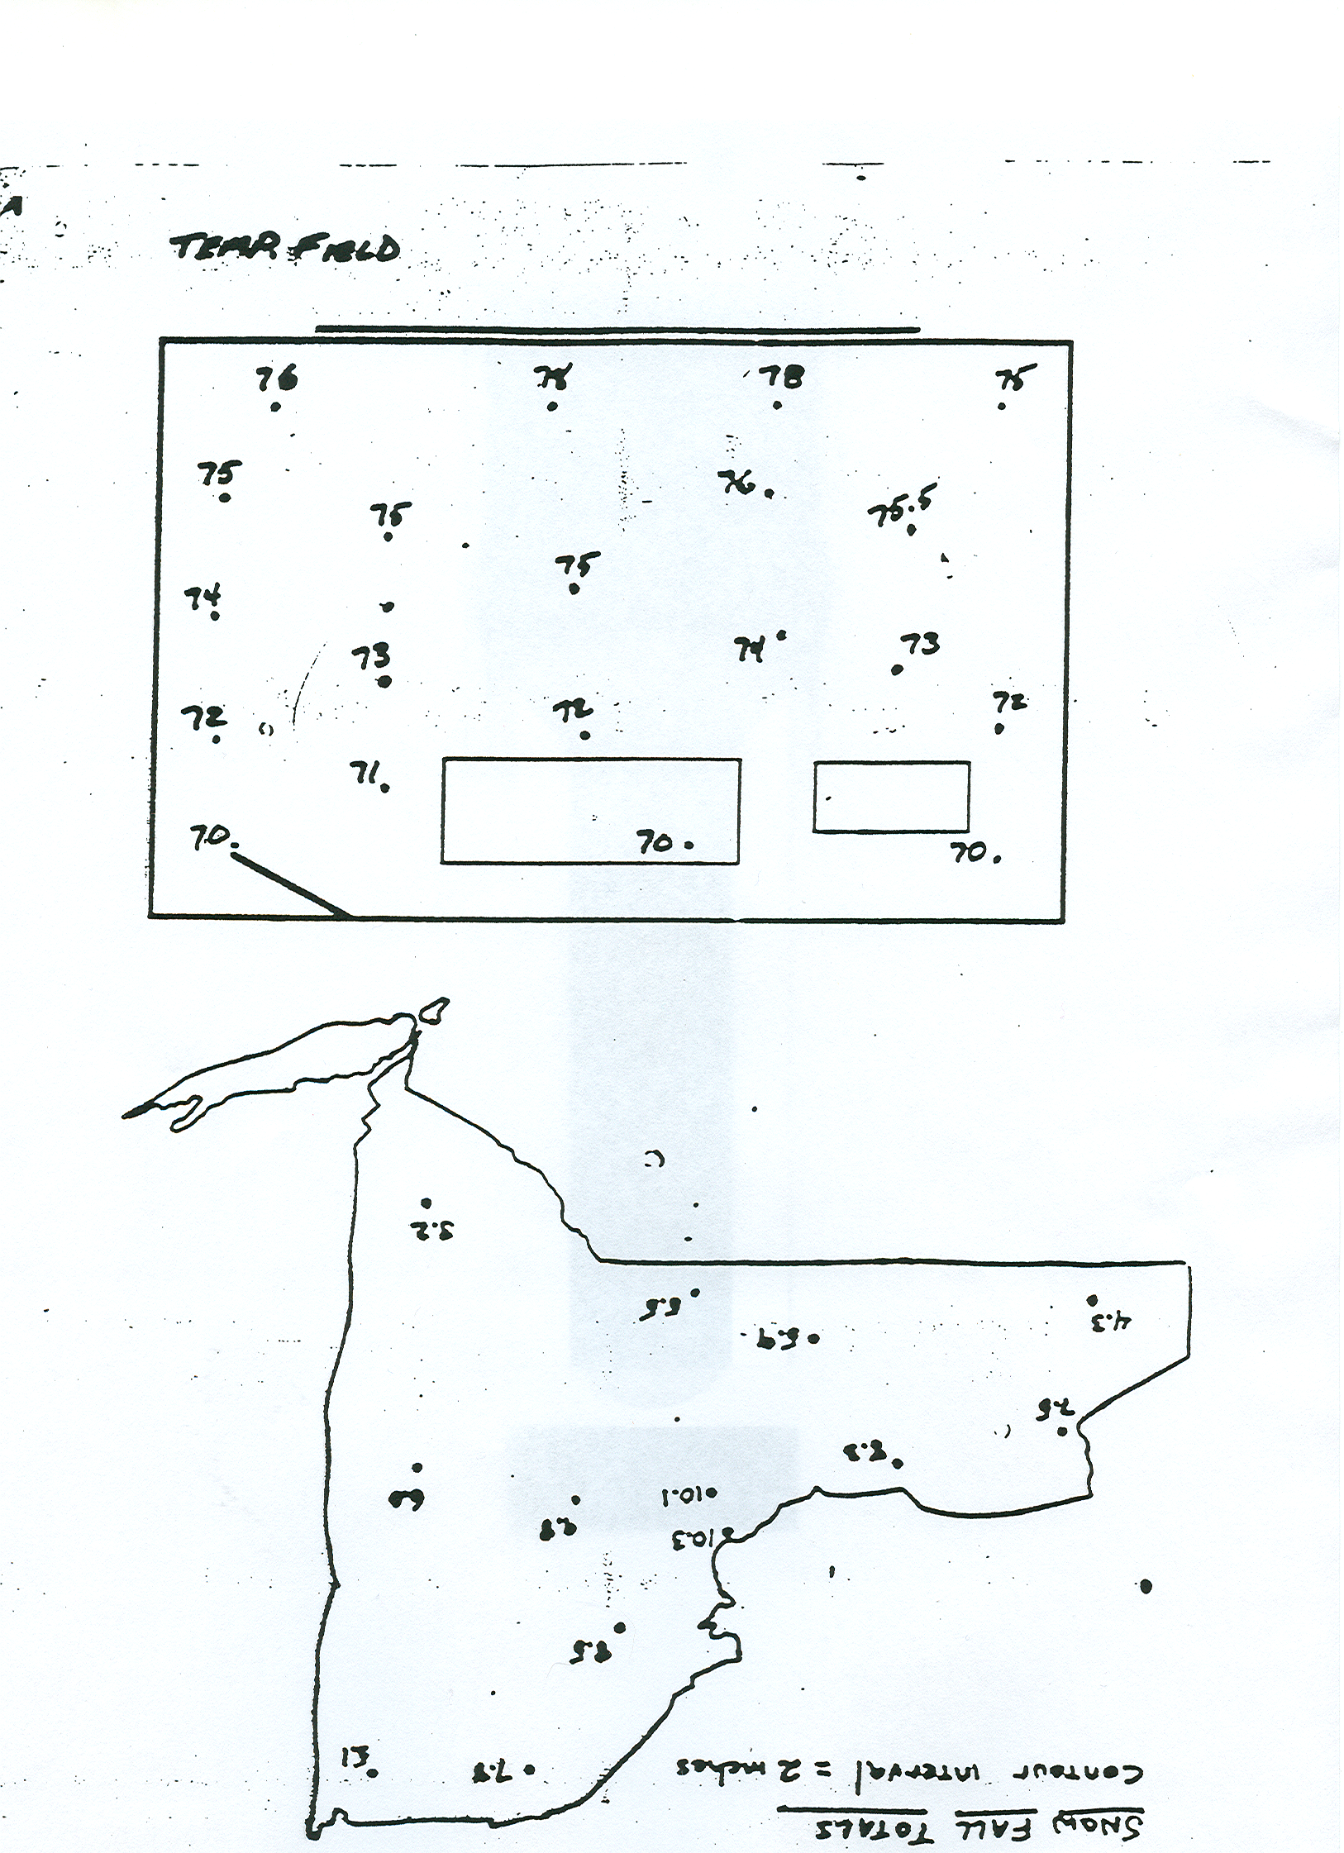

Types of Isolines:

Isotherms-

Isobars-

Contour lines-

Interval- difference in field value between isolines.

Ex:

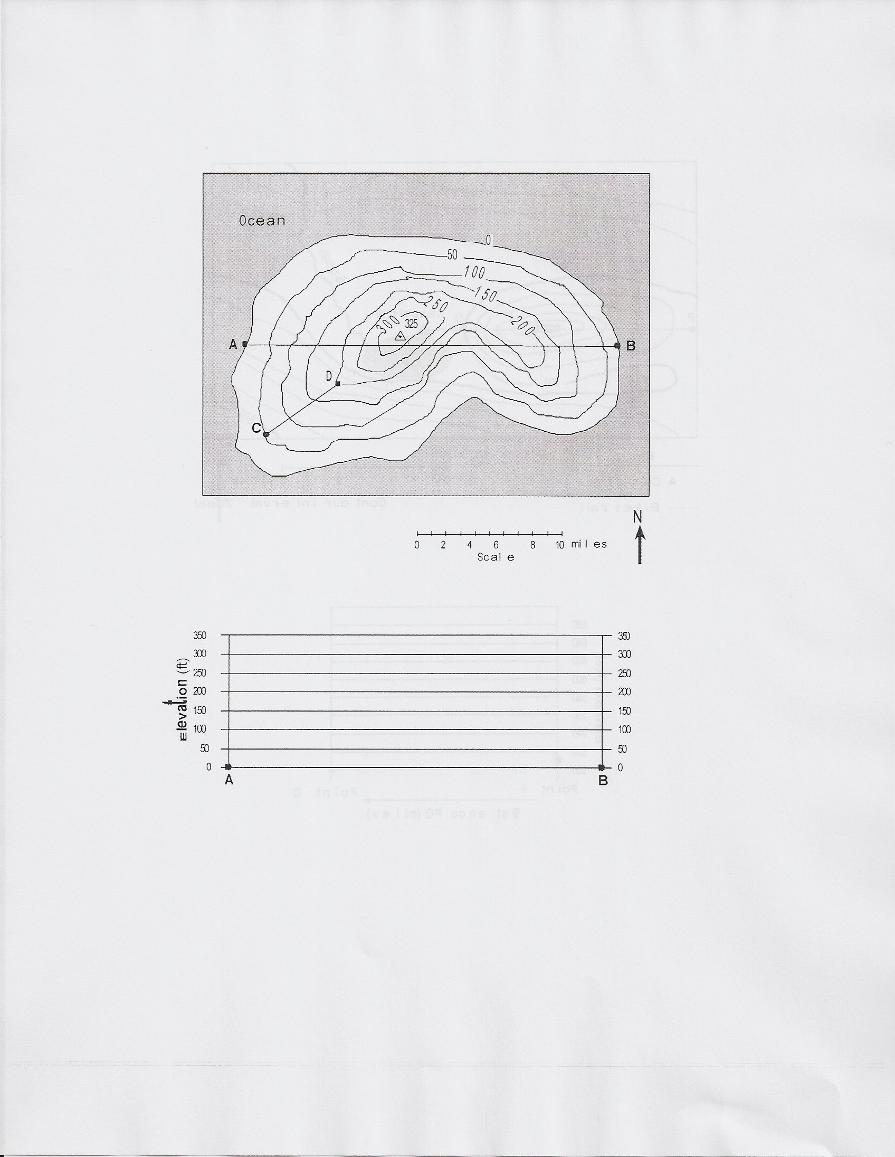
Gradient = Change in Field Value

Distance

Ex:

Contour Mapping

Topographic map- Used to show the topography ( ) of the land.

Lines connect points of equal .

Ex:

!*! See page 24 in the Review Book

Rules for Topo Maps

The closer the contour lines the the slope.

Ex:

The V’s in the contour lines that form where they cross a stream point in the that the stream flows.

Ex:

Hachures are used to show in the topography.

Ex:

PROFILES:

