EARTH MOTIONS

TOPIC 3

TRUE

MOTIONS

“Real Motions”

Rotation

Revolution

APPARENT

MOTIONS

“What appears to move”

Sun

Stars

Moon

Planets

ROTATION:

The of Earth on its .

Earth rotates from to (counterclockwise when viewed from the North Pole).

24 hours ( º/hour)

Drawing

*!* The Earths axis is tilted º relative to the sun.

REVOLUTION:

The of Earth around the sun.

days (1 º /day)

Drawing

APPARENT MOTION OF THE
STARS

Daily Motions

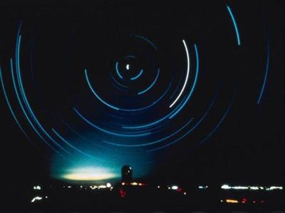
Stars appear to move in circular paths around at a rate of 15 º/hour.

Eastward to westward.

Due to .

Ex:

Annual Motion

Some constellation are while others can be seen year round.

Circumpolar vs. non-circumpolar.

Due to .

Apparent Motion of the Sun

The Sun appears to move from east to west at a rate of º/hour.

The path of the sun changes with the and with .

Local solar noon- occurs when the sun reaches its highest point in the sky.

Only between N and S will the sun ever be directly overhead! (the tropics)

The sun is NEVER overhead for an observer in the continental U.S.

See sun’s path diagram

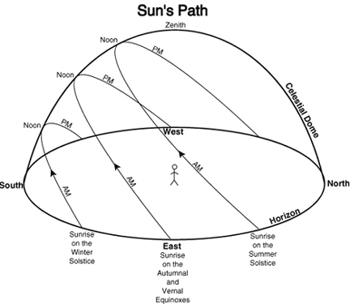

True Motions of the Moon

The Moon around Earth and on its axis once every 27 1/3 days.

The revolution of the Moon is responsible for…..

.

.

.

MOON PHASES

The varying amounts of the moon as seen from Earth.

The period from one full moon to the next is days.

http://www.astro.wisc.edu/~dolan/java/MoonPhase.html
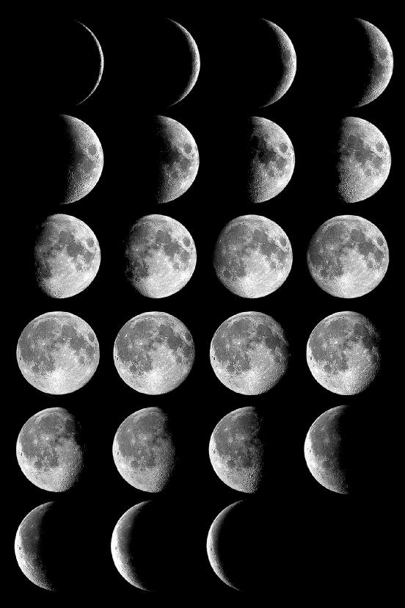
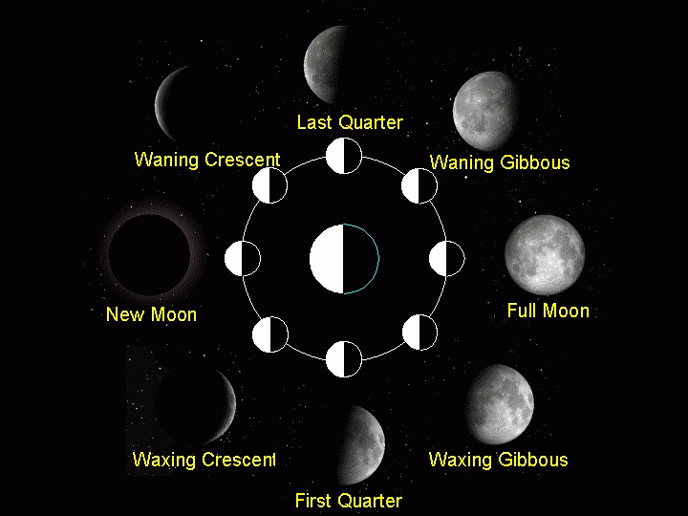

TIDES

The cyclic rise and fall of ocean waters due to the gravitation between the , and .

SPRING vs. NEAP TIDES

SPRING TIDES

Higher high tides, lower low tides.

NEAP TIDES:

Lower high tides higher low tides.

ECLIPSES:

LUNAR

SOLAR

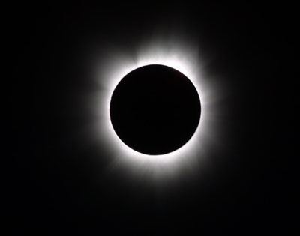
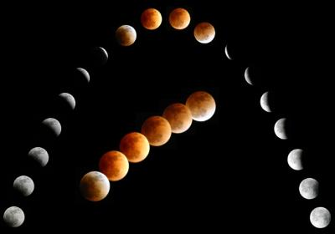

MODELS OF THE UNIVERSE

GEOCENTRIC

Ptolemy

“ Centered”

Drawing:

HELIOCENTRIC

Copernicus

“ Centered”

Drawing:

Best Evidence of the Earths Rotation…

Foucault Pendulum

Coriolis Effect- the apparent deflection of the path of a moving object due to the rotation of Earth.

N. Hemisphere – to the right

S. Hemisphere - to the left

ORBITAL GEOMETRY

Keplers 1st Law

Planets orbit the sun in slightly eccentric elliptical paths with the sun at one of the foci.
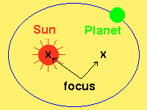

Eccentricity:

“ out of roundness”

Formula:

eccentricity = distance between foci

length of major axis

All eccentricity values must be between and (decimal)!

Kepler’s 2nd Law

A line drawn from a planet to the sun will sweep across equal areas in an equal amount of time.

What does this tell us?

The a planet is to the sun, the greater it’s orbital velocity (speed).

Kepler’s 3rd Law

The period of a planet squared is equal to it’s distance from the sun cubed. (P²=D³)

What does this tell us?

Planets that are further away from the sun take to revolve.

