TOPIC 4: EARTH IN THE UNIVERSE

“CELESTIAL ADDRESS”

UNIVERSE
- All of the , and that exists anywhere

- Age = Billion Years

The “Big Bang” Theory

- The theory that the present day universe began with a huge and is still .

Evidence:
- “Red shift” or .

- Background microwave radiation

- The left-over “bang”!

Galaxy:
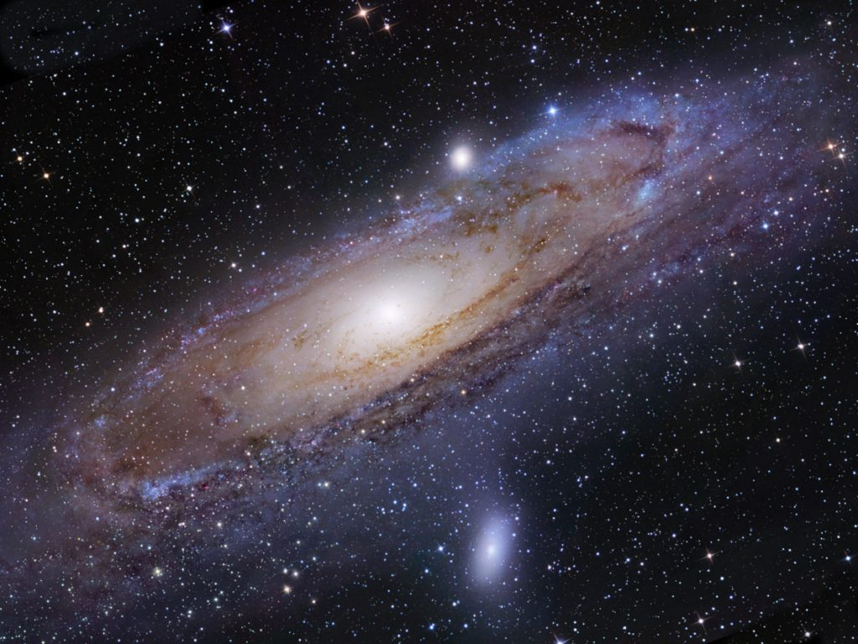
- Huge body of and other matter in space.

Drawing:

- Our sun is a star in one of the of the (spiral) galaxy

STARS:
- Usually large, self- bodies that produce their own .

Nuclear Fusion of Hydrogen

Star Classification:
- Stars are classified by and (color).

- See Reference Tables diagram p.15

- The sun is an average sized, average temperature star

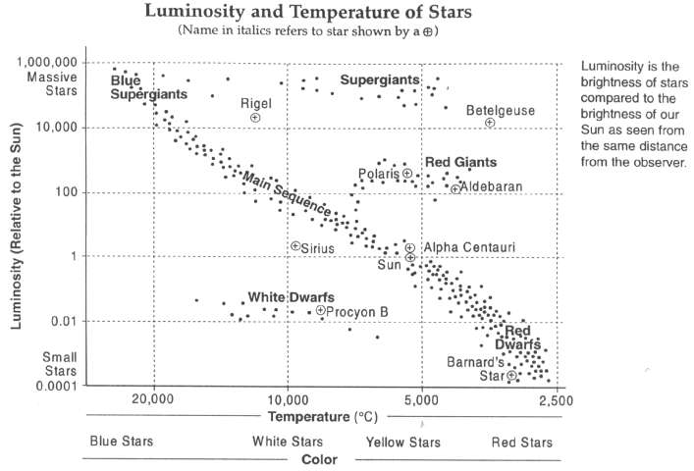

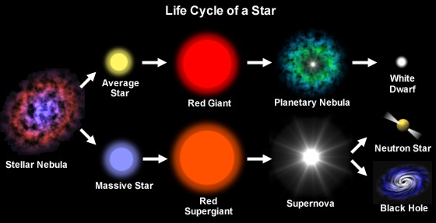

Solar System
- The and everything that around it.

Components:

- Planets

- .

- The estimated age of the Earth and solar system is .
Planets
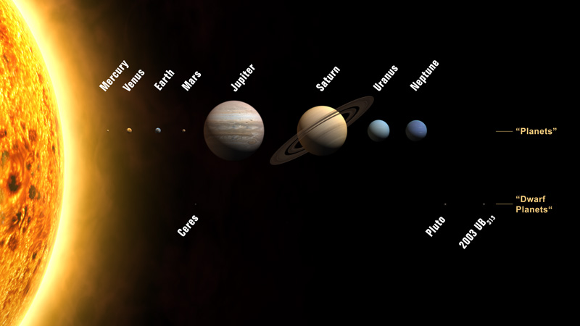

- Planets orbit the sun as the result of 2 forces…
- .
- .

Drawing:

Rocky (Terrestrial) Planets

- .

- .

- .

Gas Giant (Jovian) Planets

- .

- .

- .

Asteroids:
- Solid and/or bodies that independently orbit the sun.
- Range from 100 to 1000km in diameter.

Asteroid belt- most asteroids are in orbits between and .

- Impact events form craters and are linked to and mass .
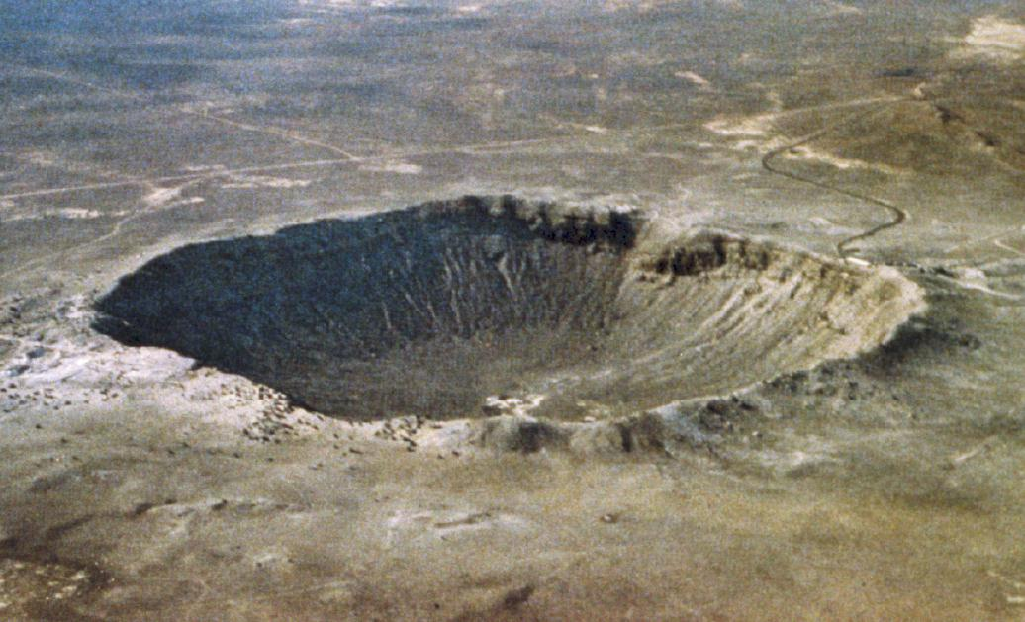

Meteoroids:
- Very solid fragments that orbit the sun.
- “Shooting Stars”- meteors that burn up or vaporize Earths atmosphere.

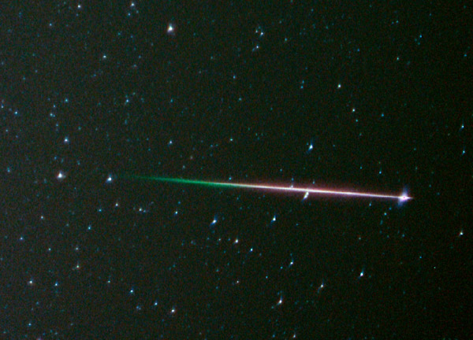

Comets:
- Chunks of and methane with rock and metallic debris.
- “Dirty Snowballs”
- Orbit the sun in highly eccentric elliptical orbits.

Tails (Drawing)

