ENERGY
TOPIC 5:

KINETIC
- Energy of .
POTENTIAL
- “ energy”



Electromagnetic Energy (EME):
- Energy that travels in the form of .

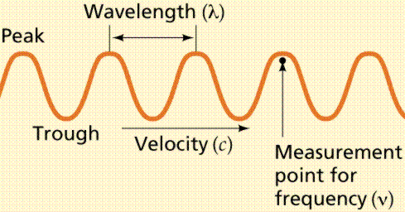

Wavelength- between two crests or troughs.
Frequency- passing a given point per second.
- As the wavelength increases, the frequency (indirect).

Electromagnetic Spectrum:
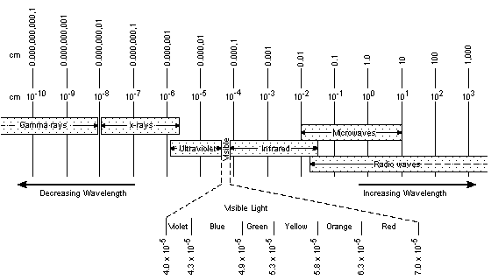
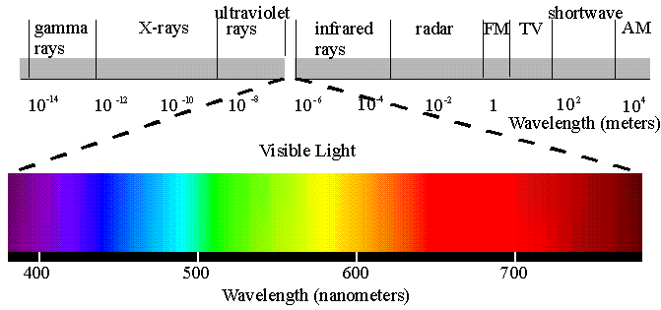
- See reference tables diagram p. 14

- The difference between the various forms of EME is their .

EME Facts:
- All EME travels at the same speed which is the speed of light (300,000 km/sec)
- Everything above absolute zero gives off EME.
- The higher the temperature, the more EME it gives off.

INTERACTIONS:
Reflection
Drawing:

- , colored surfaces are good reflectors.

Absorption
Drawing:

- , colored surfaces are good absorbers.
- Good of EME are good RADIATORS!

Refraction
Drawing:

Scattering
Drawing

HEAT ENERGY:

Heat-
the average energy of molecules.

Why is heat considered a form of Kinetic Energy?

HEAT TRANSFER:
CONDUCTION:
- Heat is transferred from to by contact
- Conduction works best in .
- Why?

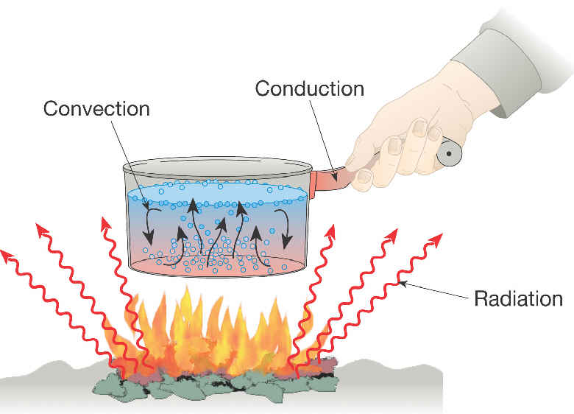
Examples:

CONVECTION:
- Heat is transferred due to differences in .
- Occurs in and only!!!
- Why?

Examples:

RADIATION:
- The transfer of heat in the form of (EME)
- No molecules are needed!!!
- Radiation is the only method by which heat can be transferred though .
- Why?

Examples:

Specific Heat & Calories
Calorie- the amount of heat needed to change 1 gram of water 1º Celsius.
Heat Lost or Gained Formula

Heat=Mass x temp change x specific heat

Examples:

Specific heat – the amount of heat needed to change the temperature of 1 gram of a substance by 1º Celsius

- See reference tables p.1
Examples:

- The higher the specific heat, the harder it is to heat up
- Liquid water has the highest specific heat
(1 cal/gram/º c)

PHASE CHANGES
Latent Heat:
Defn: Heat lost or gained during a phase change.

Solid ↔ Liquid 80 cal/g
Liquid ↔ Gas 540 cal/g

Examples:

- See reference tables p. 1

OPEN SYSTEM

- Heat lost by the source is greater than the heat gained by the sink.
- Some heat is lost.
CLOSED SYSTEM

- Heat lost by the source is equal to the heat gained by the sink.
- No heat is lost

- Heat is transferred from Hot to Cold or from Source to Sink.

