TOPIC 6 INSOLATION

INSOLATION:
Incoming Solar Radiation
- The portion of the energy that is received by the

.
Intensity of insolation- the rate at which insolation is received

- How the insolation is.

Angle of insolation- angle at which the Sun’s energy Earth

- As the angle of insolation the intensity of insolation . (direct relationship)

Factors Affecting Angle of Insolation
- TIME OF DAY
- angle increases until then decreases.

mid 6am noon 6pm mid
Angle of Insolation
Angle of Insolation

- SEASONS

- Minimum Intensity - .
- Maximum Intensity - .
- Northern Hemisphere
Jan June Dec
Intensity of Insolation

3. Latitude
- As latitude increases the intensity of insolation generally .

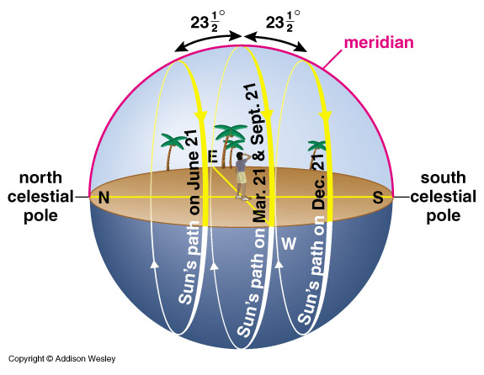
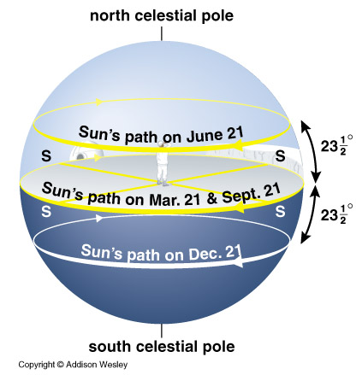
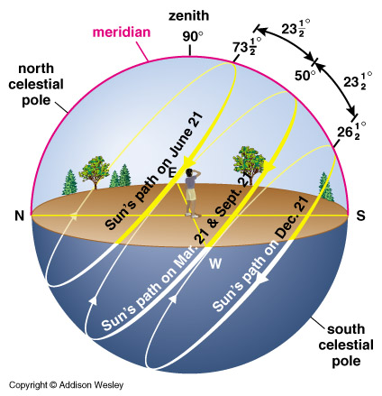

Duration of Insolation:
- Length of daylight

Factors Affecting Duration
- Seasons-
Maximum Duration – June 21 (≈15 hrs.)
Minimum Duration – Dec 21 (≈9 hrs.)
Equinox – March 21 & Sept 23 (≈12 hrs.)

2. Latitude-
as the latitude increases, the of duration increases.

Effects of the Atmosphere on Insolation
- Most radiation (UV) is absorbed in the atmosphere by .

- Most wavelengths make it to the surface.

- Infrared energy is absorbed by .
(“Greenhouse Gasses”).

- Clouds reflect insolation

- scatter insolation.

Aerosols- very fine and dispersed and suspended in the air.

Examples: dust, pollen, volcanic ash, smoke.

- As the amount of aerosols , the amount of insolation making it to Earth’s surface .

Greenhouse Effect

Drawings:
Earth
GREENHOUSE GASSES
-Carbon Dioxide
-Methane
-Water Vapor
Absorbed and re-radiated as heat (infrared)

Terrestrial Radiation-
- Energy radiated from surface.
- Infrared ( )

Radiative Balance-
- Occurs when the amount of energy absorbed by Earth = the amount of energy radiated by Earth.
How will this effect Earth temperatures over a long period of time?

Factors Affecting Absorption & Reflection of Insolation
- Color / Texture of the Surface

- Angle of Insolation

