TOPIC 7
WEATHER

Weather
Defn: The condition of the in a given place and time.

Weather Variables

1. Temperature
- Amount of in the atmosphere.

Instrument: .

- Thermometers work due to .

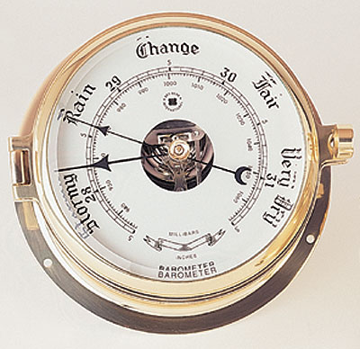
2. Air Pressure:
- The of the overlying air

Instrument: .

- Millibars and Inches of Mercury ( see ref. tables page 13)

Factors Affecting Air Pressure:
- Altitude
- As altitude increases, air pressure .

- Temperature
- As temperature increases, air pressure .

Humidity (water vapor)
- As the humidity increases, air pressure .

- All 3 are relationships!!!

- As the air temperature increases, it’s ability to hold water vapor .

OR

- air can hold more water vapor than air.

3. Relative Humidity%-
- The amount of water vapor the air holding compared to what it hold.

4. Dew Point Temperature-
- The temperature at which the air will become (rel. humidity = . % )

- occurs when the air becomes saturated.

Examples:

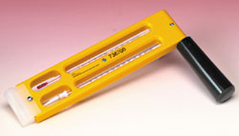

Instrument- Sling Psychrometer (wet bulb/dry bulb)
- See page 12 in Ref. Tables

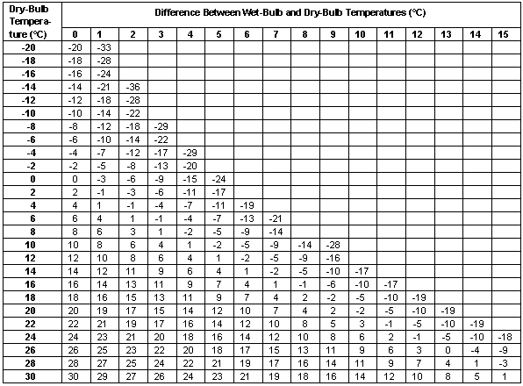
Dew Point Chart

Relative Humidity
As the temperature and the dew point get closer…
- .

- .

5.Wind
Defn: the horizontal movement of air

- Wind is caused by a (caused by the uneven heating of the Earth)

- Air moves from regions of pressure towards regions of pressure

CIRCULATION

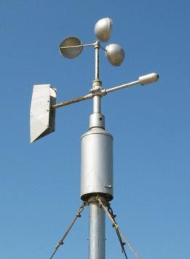

- Instrument: Vane ( )

Anemometer ( )

- Wind speed is determined by the .

- As the increases, the increases.

- The closer the isobars, the the wind speeds.

Station Model

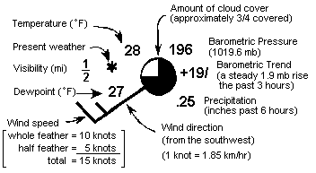

Water Cycle
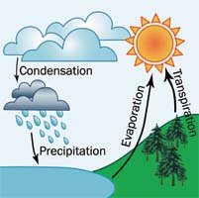

Evaporation
- Liquid to gas (water vapor)
- Requires the of heat

Transpiration- water vapor entering the atmosphere .

Factors Affecting Evaporation
- Temperature
- As temp increases, .

- Wind
- As wind increases, .

- Humidity
- As humidity increases, .

- Surface area

- As surface area increases, .

Condensation
- Gas to liquid
- Heat is to the atmosphere.

Condensation occurs when…
- The air becomes with water vapor and

- are present.

Cloud Formation
- Clouds usually form in air that is !

Precipitation:
- When water returns to the Earth’s surface.

- Occurs when the water droplets or ice crystals become .

- A method by which the atmosphere .

Examples:

Air Masses
- A “blob” of air with similar moisture and temperature characteristics.

- Air masses get their characteristics from the surface over which they form. (source region)

Temperature
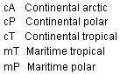
- Polar – Cold (P)
- Tropical – Warm (T)

Moisture
- Continental – Dry (c)
- Maritime – Moist (m)

WEATHER SYSTEMS

High Pressure Low Pressure

- Cool/ Dry air
- Clear/ Fair weather
- Air is sinking and diverging

- Warm/ Moist air
- Clouds & Precip.
- Air is converging and rising.

FRONTS

Cold Front
– air pushes into air.

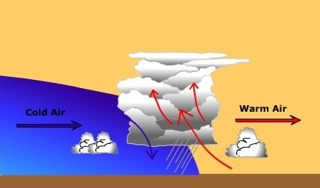

Conditions:
- Temp .
- Precip is (t-storms).
- cloud development
- Cumulonimbus clouds

Warm Front
- air displacing air.

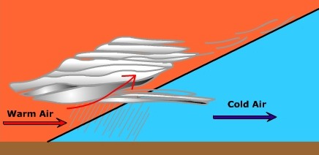

Conditions
- Temp .
- Precip. Is .
- cloud development
- Stratus clouds

Stationary Front
- the boundary between warm and cold air remains in the same place.

Conditions:
- Weather similar to a warm front.

Occluded Front:

- Occurs when a cold front catches up to a warm front in a wave cyclone.

Wave Cyclone

Occluded Front:

