Name:

**The Cell and Body Systems Study Guide**

1. An organism that is made of just one cell is known as _____________________________. Complex organisms made of multiple cells are known as ___________________________.
2. Create a time line for the history of the microscope (similar to the time line we created as a bell ringer) Include the last name of the individual and a general idea of what they did that was important.

3) Cell Theory has 3 main components:

1)_____________________________________________________________________________

2) ____________________________________________________________________________

3) ____________________________________________________________________________

4) Cells can’t be too large. Cells want to maximize their volume to surface area ration. Why is it important that they don’t become so large?

5)_____________________ cells do not have either membrane bound organelles or a nucleus, while ____________________________ cells have both membrane bound organelles and a nucleus.

6) Eukaryote organisms are ___________________________________________________________

Prokaryotic organisms are ______________________________________________________________

7) Give the purpose/job of each organelle:

a) Mitochondria

b) Nucleus

c) Ribosome

d) Golgi apparatus

e) Cytoplasm

f) Chloroplasts

g) Vacuole

h) Lysosome

i) Endoplasmic Reticulum

j) Cell Wall

8) The Cell membrane is a very complex part of the cell. What are the three main functions of the cell membrane?

A)

B)

C)

9) Label the image below: You may use the word bank given:

*exterior of cell, phospholipid, Cholesterol, Glycolipid, Carbohydrate, transmembrane (intergral) protein, glycoprotein, Peripheral Protein, Interior of cell, hydrophobic head, hydrophilic tail*

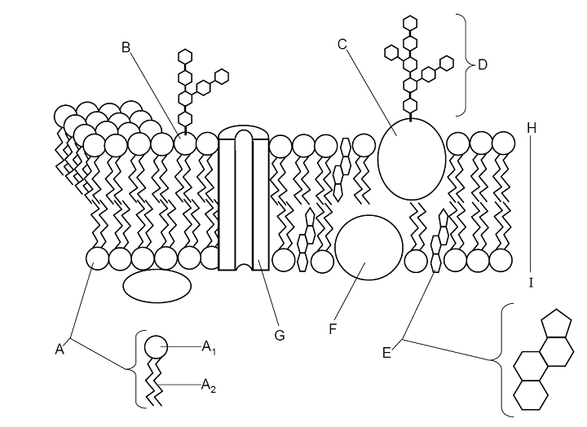

10) A gated Channel opens and closes for _____________________________ while a carrier molecule aids in the moment of materials through the ______________________________. _______________ are used to move water in and out of the cell with speed.

11) The cell membrane is always in _______________________. Particles are constantly moving and bumping into each other. In general there are only two ways to move across the cell membrane. You can either use energy in the form of ATP, which is called ______________________. Or no energy needs to be used and molecules can flow through the membrane by ________________ transport. Active Transport is defined as the movement of molecules from an area of ___________ concentration to an area of _____________ concentration which requires energy.

12) Describe what happens in the sodium potassium pump:

13) The sodium-potassium pump is important because it creates an _______________________ gradient across the cell membrane. This is important for _______________________________ and resulting movement.

14) Passive transport is divided up into two separate categories. ________________________________ is when a carrier molecule can allow a specific molecule to pass through the membrane. This protein may open and close for this specific molecule. Diffusion on the other hand is the movement of molecules from ___________________________________________________________________ until they become evenly distributed. Neither form of movement requires energy to occur.

15) The movement of water across the membrane is given a special name. It is called __________________________.

16) Endocytosis is when the cell membrane slowly wraps around a molecule and ___________________________________________________. White blood cells do this to _____________________. Endocytosis can occur to solids and when that happens it is called ________________________. When liquids undergo endocytosis this is called _______________________________. Exocytosis is the movement of molecules from the golgi body to ___________________________________________.

17) If molecules are too big to enter the cell they will be broken down through the process ______________________. Once inside the cell, these molecules can be reconstructed through the process __________________________.

18) Some proteins in the cell can receive chemical messages from other cells, these molecules that receive signals are known as ______________________________________. Chemicals that travel through the body produced by the endocrine glands are known as ____________________________. Both chemical and electrical impulses are extremely important because they help to support _________________________, which is an internal balance within the body.

19) Be able to list the differences and similarities between plant and animal cells.

20) Create a flow chart that shows the increase in complexity starting with the cell and ending with organisms.

21) Give a brief overview of the purpose of the body systems below:

a) Digestive System

b)Respiratory System

c) Circulatory System

d) Excretory System

f) Movement

g) Coordination

h) Immunity

i) Reproductive System

22) Complete the following chart:

|  |  |  |
| --- | --- | --- |
| Function | Single Cell | Multicellular Organism |
| Gas Exchange |  |  |
| Transport of Substances |  |  |
| Nutrition |  |  |
| Excretion |  |  |