Name: _________________________________________ Period: _____

*At this time of the year, time is a factor. We don’t have too much time to review but I feel that these practice questions will be VERY helpful in reviewing the material from this chapter. It should be brought to your attention that these questions are pretty difficult so take your time in researching the answers. Good luck!*

1. Bacterial viruses (phage)
   1. Can reproduce on their own.
   2. Require a host cell to replicate.
   3. Carry out metabolism.
   4. Have a plasma membrane.
   5. Are alive.
2. Retroviruses have a gene for reverse transcriptase that
   1. Uses viral RNA as a template for making complementary RNA strands.
   2. Protects viral DNA from degradation by restriction enzymes.
   3. Destroys the host cell DNA.
   4. Translates RNA into proteins.
   5. Uses viral RNA as a template for DNA synthesis.
3. The herpes virus
   1. Acts as a provirus when it’s DNA becomes incorporated into the host cell’s genome.
   2. Is a retrovirus that uses restriction enzymes to transcribe DNA from its RNA genome.
   3. Is the retrovirus that has been linked to HIV, the virus that causes AIDS.
   4. Can be used to vaccinate against hepatitis B.
4. Operons
   1. Are common in eukaryotes.
   2. Consist of structural genes only.
   3. Consist of a promoter, an operator, structural genes, and a repressor gene.
   4. Include inducer genes.
   5. Are always expressed.
5. In *E. coli*, tryptophan switches off the *trp* operon by
   1. Inactivating the repressor protein.
   2. Binding to and activating the repressor protein.
   3. Binding to the operator.
   4. Binding to the promoter.
6. A mutation that renders nonfunctional the product of the regulatory gene for an inducible operon would result in
   1. Continuous transcription of the genes of the operon.
   2. Complete blocking of the attachment of RNA Polymerase to the promoter.
   3. Irreversible binding of the repressor to the operator.
   4. No difference in transcription rate when an activator protein was present.
   5. Negative control of transcription.
7. A plasmid
   1. Is the bacterial genome.
   2. Is a small, circular, double-stranded DNA molecule.
   3. Is only recombinant.
   4. Does not code for proteins.
   5. Is double-stranded DNA.
8. The replication of the genome of an RNA virus uses
   1. DNA Polymerase from the host.
   2. RNA replicating enzymes coded for by viral genes.
   3. Reverse transcriptase to synthesize RNA.
   4. Restriction nucleases from the host.
9. The replication of the genome of a DNA virus uses
   1. DNA Polymerase from the host.
   2. RNA replicating enzymes coded for by viral genes.
   3. Reverse transcriptase to synthesize RNA.
   4. RNA Polymerase from the host.
   5. Restriction nucleases from the host.
10. Which of the following is a source of genetic variation in bacteria caused by a virus
    1. Transposon
    2. Transformation
    3. Transduction
    4. Conjugation
    5. Mutation
11. Gene amplification involves
    1. The enlargement of chromosomal areas undergoing transcription.
    2. The synthesis of extra copies of genes.
    3. The transformation of genes into tumor-suppressor genes.
    4. An enhancer or promoter that is activated and increases transcription rate.
12. Heterochromatin
    1. Has a higher degree of packing than does euchromatin.
    2. Is visible with the light microscope during interphase.
    3. Is not actively involved in transcription.
    4. Make up the more densely packed chromosomes seen during metaphase.
    5. Is all of the above.
13. DNA methylation of DNA
    1. Can be induced by drugs that reactivate genes.
    2. May contribute to gene inactivation.
    3. Produces the promoter regions that specifically bind RNA Polymerase.
    4. Makes satellite DNA as a different density so it can be separated by ultracentrifugation.
    5. May be related to the transformation of proto-oncogene to oncogenes.
14. “Sticky ends”
    1. Form associations with complementary RNA that are very stable.
    2. Have non-specific base sequences.
    3. Must interact with each other in the formation of recombinant DNA
    4. Are the results of staggered cuts of DNA by restriction enzymes.
15. A host cell or organism that contains recombinant DNA is referred to as a ________ cell or organism.
    1. Transfected
    2. Transformed
    3. Transgenic
    4. Chimeric
    5. Selectable
16. The role of the restriction enzymes in DNA technology is to
    1. Provide a vector for the transfer of recombinant DNA.
    2. Produce cDNA from mRNA.
    3. Produce a cut (usually staggered) at specific recognition sequences on DNA.
    4. Reseal “sticky ends” after base-pairing of complementary bases.
    5. Digest DNA into single strands that can hybridize with complementary sequences.
17. This restriction fragment contains a gene whose recessive allele is lethal. The normal allele has restriction sites for the restriction enzyme PST1 at sites I and II. The recessive allele lacks restriction site I. An individual who had a sister with the lethal trait is being tested to determine if he is a carrier of that allele. Indicate which of these band patterns would be produced on a gel if he is a carrier (heterozygous for the gene)?

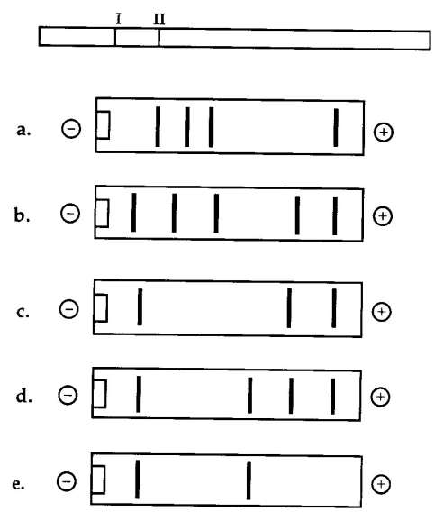

1. This segment of DNA has restriction sites I and II which create restriction fragments a, b, and c. Which of the following gel(s) produced by electrophoresis would represent the separation and identity of these fragments?

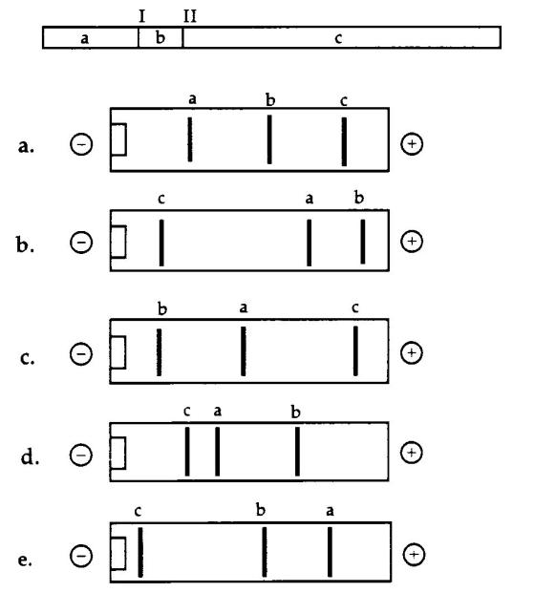

*Use the following choices to answer questions 19-22.*

* 1. Restriction enzyme
  2. Reverse transcriptase
  3. Ligase
  4. DNA Polymerase (specifically Taq Polymerase)
  5. RNA nuclease

_______ 19.) Which enzyme would be the first used to produce cDNA?

_______ 20.) Which enzyme would be used in the polymerase chain reaction?

_______ 21.) Which is the first enzyme used in the production of DNA fragments for

DNA fingerprinting?

_______ 22.) Which enzyme would likely be used in order to reseal “sticky ends?”

1. Make sure you know how conjugation, transduction, and transformation are all different from each other…yet know how they are all similar.
2. Make sure you know the examples of biotechnology. PCR, Gel Electrophoresis, Genetic Engineering, and Cloning.
3. Know the different types of viruses, examples of each, and how they reproduce. Got it?
4. *Lac operon* and *trp operon*. How do they function? How are they different? How are they similar?