Unit 10 – Animal Form & Function Study Guide - AP Biology

* Key Vocabulary to know, be able to use, and/or recognize
  + 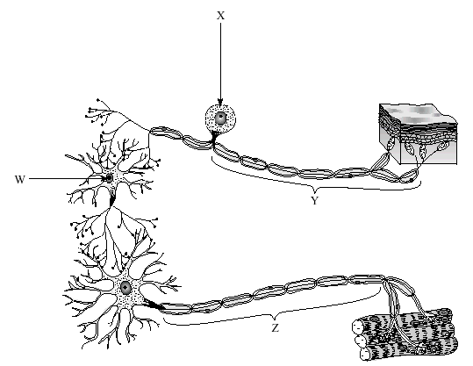Endotherm, Ectotherm, poikilotherms, homeotherms, Symaptheic nervous system, Parasympathetic nervous system, all-or-none response, circadian rhythm, norepinephrine, peristalsis, fibrinogen, positive feedback, negative fceedback, receptor, transduction, response, ligand, G-protein
* Digestive System
  + Know the purpose of each organ in the digestive system
  + Be able to recognize what each organ in the system is from an image
  + Know what enzymes are used for digestion and where each can be found
    - Know if unactivated or activated
  + Purpose of saliva and villi
  + Know where fats, proteins, and carbs are digested
* Nervous System
  + Know each part of the brain and its purpose
  + Be able to recognize and know what is the purpose of the action potential graph (showing membrane potential vs time)
  + Know the steps of the action potential and the movement of the ions that create this potential
  + Difference between PNS and CNS
  + Types of neurons and their purpose
    - Movement of a stimulus through those types of neurons
* Endocrine System
  + Each of the hormones given, the purpose of each, where they are produced/what they activate
  + Difference between anterior and posterior pituitary gland
  + Differences between steroid and protein hormones
* Excretory System
  + Know the purpose of each organ in the excretory system
  + Be able to recognize what each organ in the system is from an image
  + Know/Identify the parts of a nephron and their purpose
  + 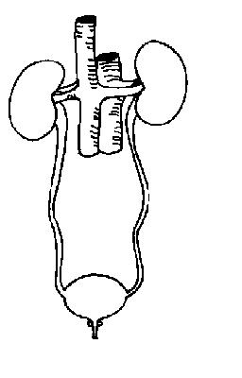How does the excretory system maintain water levels in organisms
  + types of organisms and their type of nitrogenous wastes
* Respiratory System
  + Know the purpose/recognize parts of the respiratory system
  + How do some organisms breath through their skin
  + How does the body stop food from enter the lungs
  + How does an organism stop dust from entering the lungs
  + Difference between fetal hemoglobin and adult hemogloin
* Circulatory System
  + Be able to recognize what each part of the heart from an image
  + Know the purpose of each part of the heart
  + Know/recognize the areas of deoxygenated and oxygenated blood
  + Movement of blood in general through body
  + What are the components of blood and their purpose
  + What causes a heart murmur
  + How does blood make it back to the heart with a lack of pressure after reaching capillaries
  + How is the lub-dub sound in the heart beat created
  + Blood pressure measurements (systolic vs diastolic)
  + Differences between open and closed circulatory systems
  + What affects hemoglobins affinity for oxygen
  + Arteries vs. veins
* Immune System/lymphatic system
  + Where are immune cell produced
  + What types of cells are there and what is the purpose of each
  + Specific and nonspecific defenses of the immune system
    - Layers of nonspecific responses
  + Difference between primary and secondary response
  + Active immunity vs passive immunity
* What happens when you are being chased by a bear?
* Why can some organisms have gastrovascular cavities but other organisms cannot have them?
* How does an organism increase its body temperature
* How does human blood maintain a healthy pH? How is pH affected by changes in oxygen and carbon dioxide levels? How does an increase in CO2 cause an issue?

