* Stages of the Cell cycle
  + Each stage, what happens in each, relative length of each stage and how it applies to the overall process of mitosis
  + Regulation of each stage
  + Genetic content at each stage
  + Differences in cytokinesis in animal vs plant cells
  + Visually recognize each stage of the cycle
* Overall importance and implications of cell division/mitosis in organisms
* What the cells activity and genetics is like in stages of nondivision
* What types of cells undergo and result from mitosis and meiosis
  + Cell types that do not undergo mitosis/meiosis
* Vocabulary referring to genetic content as well as components within the cell cycle
* How the cell cycle applies to cancers
* Meiosis
  + Stages, where meiosis takes place, cells resulting, genetic content within each stage
  + Nodisjunction and resulting disorders, polyploidy
  + Crossing over and genetic variation
  + Variation within male and female offspring
* Difference and similarities between mitosis and meiosis
  + In stages, genetic content, location of cells, cell types
* Karyotyping
* 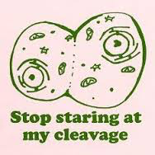How mitosis and meiosis apply to asexual vs. sexual reproduction and advantages and disadvantages of each.

